This document is designed to describe the operations of the TP-Link devices in the SmartThings application. It is a single document for all supported devices. A separate file, “TP-Link Server Installation.txt” provides installation instructions.

Supported Devices, Device Handlers, and Functionality
Supported devices and test status:
- SmartThings Device Handler: "TP-Link_Plug_Switch.groovy".
Functions: on/off; refresh.
a. HS-100 - tested.
b. HS-105 - not tested. Assume same as HS-100.
c. HS-110 - not tested. Assume same as HS-100.
d. HS-200 - tested.
2. SmartThings Device Handler: "TP-Link_LB-100_110.groovy"
Functions: on/off; brightness; refresh.
a. LB-100 - function tested on LB-120. Assume operates.
b. LB-110 - function tested on LB-120. Assume operates.
3. SmartThings Device Handler: "TP-Link_LB-120.groovy"
Functions: on/off; brightness; color temperature; circadian; refresh.
- LB-120 - tested.
4. SmartThings Device Handler: "TP-Link_LB-130.groovy"
Functions: on/off; brightness; color temperature; circadian; color; refresh.
a. LB-130 - tested.
TP-Link Bridge Interface. The “TP-LinkServer.js” node file includes interfaces to the “TP-LinkBridge.groovy” device handler. This independent applet provides the state of the “TP-LinkServer.js” node applet plus a means to reboot the server. Although the bridge interface is implemented, it is not required for any device control / status function to work. A separate GitHub repository contains the TP-LinkBridge files and description.
State Machine. The application is designed as a state machine. In this implementation, setting the device through SmartThings will send a command through the NodeServer to the device. The device then returns the state that is used by SmartThings to update the internal (displayed) state based. The only exception are the power transition states of "TURNINGON" and "TURNINGOFF"; which are set internally to this application.

Functional Description
This section is in reference to the main screen for each device (accessed by depressing the device label (name) on the SmartThings application. Below is the main screen for the LB-130 bulb. All others are derived from subtracting from this main screen.
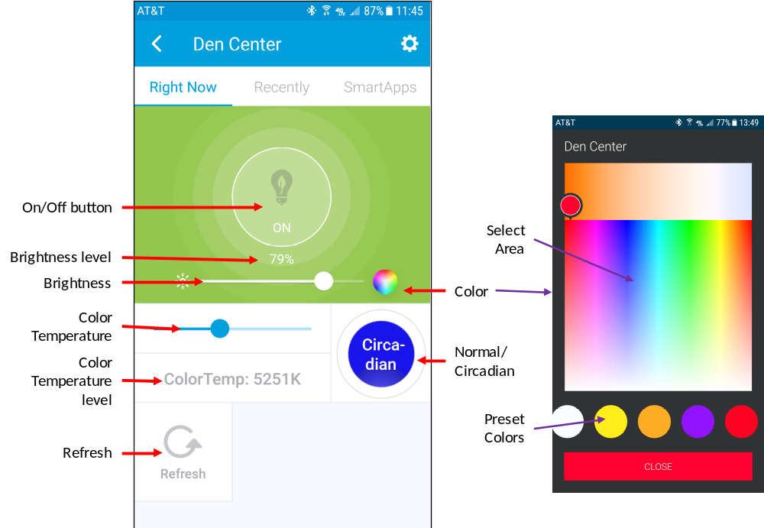
Error Indications
Applicable: All.
SmartThings to Bridge Communications Error. This is indicated by the On/Off button being a steady yellow. The cause is that the command was sent but SmartThings did not parse the return (either not processed by SmartThings or not sent by the Bridge.
Corrective Actions to try:
- Press the refresh button. If corrected, then it was transitory.
- Check the operation of the bridge PC and the PC software. Some items:
- The IP address of the bridge may have changed.
- Power on the PC and your router.
- The application is running.
TCP-Link Device TCP Error. This is indicated by the On/Off button being a steady orange and the message “TURNING ON” or “TURNING OFF”. The cause is that the TP-Link device is off-line.
Corrective Actions to try:
  - Press REFRESH on the device being controlled.
  - Go to the TP-LinkBridge device (if installed) and check the status.
  - Turn the TP-Link device off then on. Wait about a minute and try again.
  - Check the TP-Link device IP address and assure it has not changed.
Function: Refresh
Applicable: All.
Action: Touch the Refresh button. This will update the state of the device from the device.
Use: This is used of you notice the device state is other than that displayed in SmartThings.
Corrective Action: If refresh does not work, you can try the following:
a. Verify that SmartThings is operating by controlling some other device.
b. Verify the PC-based server is operating.
c. Try controlling the device through the Kasa application.
d. Physically turn-off or unplug the device.
Function: On/Off
Applicable: All.
Action: Touch the on-off button to toggle power.
Display states:
a. ON. Color is blue.
b. TURNINGOFF - device sent OFF command and SmartThings is waiting for a response from device. COLOR is ORANGE.
c. OFF. Color is white..
d TURNINGON - device sent ON command and SmartThings is waiting for a response from device. COLOR is ORANGE.
e DEVICE OFFLINE – the Bridge had trouble communicating with the TP-Link device. COLOR is ORANGE. Indicates the device is not on the network, has a different IP address, or is unplugged/unpowered.
Notes (bulbs only):
- Off. Turning bulb off when in circadian mode will also set the bulb to normal mode (this is a bulb function).
- On. When turning on the bulb, it will turn on to the setting at the last off state. Exception: see above.
Function: Brightness
Applicable: Bulbs only.
Action: Touch and slide the slider to change brightness.
Display: Displays the interger value of bulb brightness (0 - 100).
Notes:
- If the bulb is off, changing the brightness will turn on the bulb at the new brightness.
- For the above, if the bulb is was color when turned-off, it will return to the previously selected color.
- If you change the brightness to “0”, the bulb will go to the lowest possible brightness; however, the status will state brightness as “0”.
- If the brightness is “0” and you turn on the bulb, the bulb will act as above.
Function: Color Temperature
Application: LB-120 and LB-130 bulbs.
Color Temperature Ranges:
a. LB-120: 2700 to 6500.
b. LB-130: 2500 to 9000.
Action: Touch and slide the slider to change color temperature.
Notes:
- If the bulb is off, changing the color temperature will turn on the bulb.
- On the LB-130, the color temperature will appear as zero when a color has been selected.
- On the LB-130, changing color temperature from zero will return the bulb to non-color at the selected color temperature.
Function: Circadian (and Normal)
Application: LB-120 and LB-130 bulbs.
Action: Touch the tile labeled “Normal” to toggle to Circadian.
Notes:
- Selecting Circadian will automatically turn the bulb on.
- Circadian emulates outside light levels by controlling brightness and color temperature.
- Turning the bulb off will also transition the bulb to Normal (this is a bulb function).
Function: Color Temperature
Application: LB-130 bulb.
Action: Touch the color wheel on the power tile. Then select the desired color either by touching the desired color on the color tile or selecting the preset color at the bottom of the page.
Notes:
- If the bulb is turned off, the bulb will automatically turn on when selecting a color.
- Selecting Circadian or changing the color temperature will return the bulb to non-color.

